

NOTRE DAME UNIVERSITY
BANGLADESH
Lab Task - 02

Course Title: Technical Writing & Presentation Lab
Course Code: CSE 3207

Submitted by:
Name: Istiak Alam
ID: 0692230005101005
Batch: CSE-20
Submission Date: 05-02-25
Assignment Topic: Making Document in Texmaker

Submitted to:
Md. Tahmid Hasan,
Lecturer, Depertment of CSE,
Notre Dame Univesity Bangladesh
Lab Task-02 :
Code in Texmaker :
\documentclass{article}
\begin{document}
\title{Practice Lab-02 :}
\author{Istiak Alam}
\maketitle
\textbf{Mathamatical Equation:} \\
1. $\int k\ dx = kx + C$ \\
2. $\int x^n\ dx = \frac{1}{n+1}x^{n+1}+C,\ n \neq -1 $\\
3. $\int x^{-1}\ dx = \int \frac{1}{x}\ dx = ln|x|+C$ \\
4. $\int \frac{1}{ax+b}\ dx=\frac{1}{a}ln|ax+b|+C$ \\
5. $\int ln(x)\ dx = x ln(x) -x + C $ \\
6. $\int e^x\ dx = e^x + C$ \\
7. $\int cosx\ dx = sinx + C$ \\
8. $\int sinx\ dx = -cosx + C$ \\
9. $\int sec^2x\ dx = tanx + C$ \\
10. $\int secx\ tanx\ dx = secx + C$\\ \\
11. $\int cscx\ cotx\ dx = -cscx + C$ \\ \\
12. $\int csc^2x\ dx = -cotx + C$ \\ \\
13. $\int tanx\ dx = ln|secx| + C$ \\ \\
14. $\int secx\ dx = ln|secx+tanx| + C$ \\ \\
15. $\int \frac{1}{(a^2+u^2)}\ dx = \frac{1}{a}tan^{-1}(\frac{u}{a})+C$ \\
16. $\int \frac{1}{\sqrt[]{a^2-u^2}}\ dx = sin^{-1}\frac{u}{a}+C$
\end{document}

Output in Texmaker :

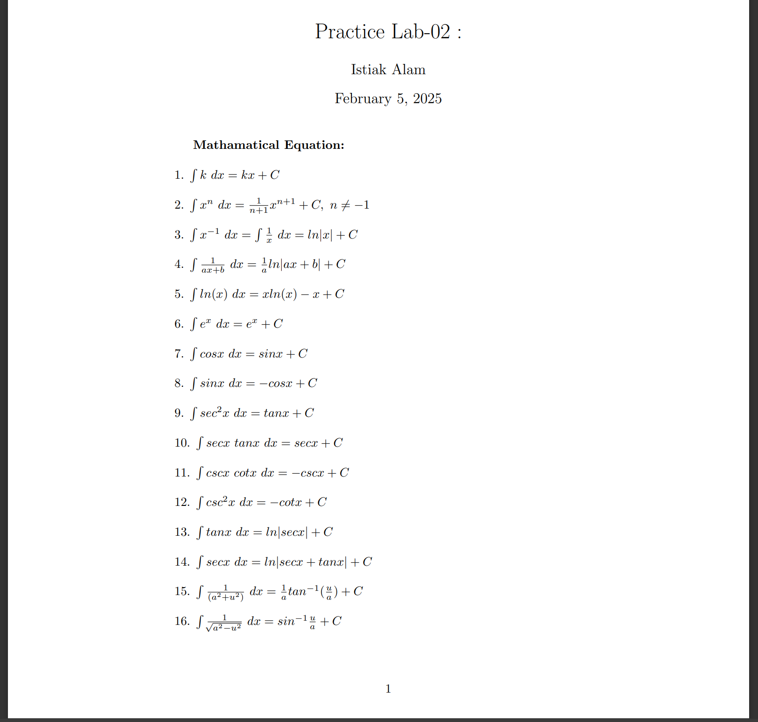Figure 1: Output in PDF

